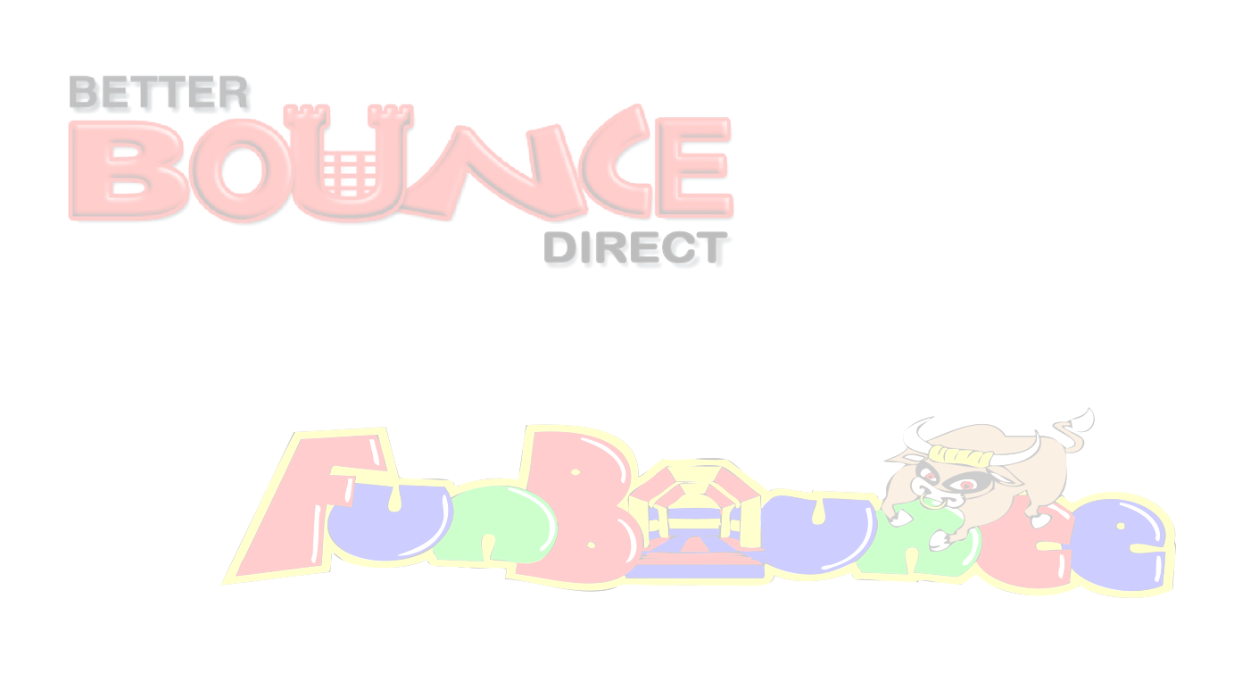
Risk Assessment – Ball pool
Hazard Area | Risk | Existing Controls | Likelihood  1 - 5 | Severity  1 - 5 | Risk Score  L x S | Further Action to take
Ball Pool | Over enthusiastic participants | Responsible person supervising at all times. | 2 | 1 | 1 | In the event of large numbers of participants trained operators should be supplied with the inflatable to aid with large numbers.
Ball Pool | Jumping over unit | Responsible person supervising at all times. | 1 | 1 | 1 | In the event of large numbers of participants trained operators should be supplied with the inflatable to aid with large numbers.
Ball Pool | Danger of unnecessary injury. | Ensure that no one with a history of back or neck problems or who suffers from a heart complaint uses the Inflatable or anyone who is feeling unwell or suffering the effects of alcohol or drugs & Pregnant women may NOT use any equipment at anytime. | 1 | 5 | 5 | None
Ball Pool | Overloading or Tipping over. | No user weighing over 90kg or 14 stone is permitted to us the equipment at any time. | 1 | 5 | 5 | None
Ball Pool | Larger participants colliding with smaller participants | Responsible person supervising at all times. | 1 | 1 | 1 | Participants put in to groups of similar size.
Ball Pool | Adverse weather conditions. | The item will be switched off in heavy rain and is not permitted to run in strong winds over 24mph as both these conditions can be deemed a health and safety risk. This risk must be used in conjunction with our weather-safety-advice document. | Dependant on weather | Dependant on weather | Dependant on weather | Use a wind speed meter at all times and close the equipment when predicted speeds are over 24mph including gusts. Use the met office for data; https://www.metoffice.gov.uk/public/weather/forecast
Ball Pool | Chocking on balls | Do not allow children to come into contact with balls unsupervised | 1 | 4 | 4 | None
Ball Pool | Injury through lack of supervision. | At least 2 fully trained operators must be present with the equipment at all times, 2 per entrance and exit is advised. | 1 | 5 | 5 | In the event that the supervisors must leave there post, Equipment must be switched off and not used.
Ball Pool | Tripping over anchorage points, spare equipment, electrical cables | Anchor points used as per manufacturers instructions and spare equipment erected safely or stowed away. Where possible electrical cable does not cross any public pathway. | 1 | 1 | 1 | In the event of large numbers of participants attending or large events, additional safety fencing is erected, electrical cables will be erected overhead or covered and
Ball Pool | Injury through incorrect positioning. | Do not move or try to reposition the equipment under any circumstances and ensure that the anchors are in place at all times. | 1 | 2 | 2 | None
Ball Pool | Petrol Blower, Generator  Risk of fire | Blowers/generators filled with fuel before delivery, units are fire retardant. | 3 | 1 | 1 | All spare fuel is stored in suitable marked container, and in a safe location, units switched off during re fuelling,
Ball Pool | Choking | No food drinks or chewing gum to be allowed on or near the equipment. | 1 | 4 | 4 | None
Ball Pool | Injury through 3rd party items | All shoes, glasses, jewellery, badges MUST be removed before using this piece of equipment. | 1 | 5 | 5 | None
Ball Pool | Danger of fire. | No smoking or barbecues near the equipment at any time. | 1 | 5 | 5 | None
Ball Pool | Injury through insecure anchorage. | Never use this unit without proper anchorage in place, It may be blown over in certain wind conditions, If the inflatable unit is not anchored correctly please ensure you tell the erection team before they leave as we keep a tight schedule and may not be able to return immediately. | 1 | 3 | 3 | None
Ball Pool | Injury through 3rd party & spectators. | Always ensure that the area surrounding the equipment is not overcrowded. | 2 | 3 | 6 | None
Ball Pool | Emergency | In the event that someone is seriously injured, DO NOT move the individual, leave the equipment switched on and dial 999 immediately. | 1 | 5 | 5 | None
Ball Pool | Injury through lack of inflatable pressure or suffocation. | Do not allow anyone to be on the equipment during inflation or deflation as this can be EXTREMELY DANGEROUS. | 1 | 2 | 2 | None
L=Likelihood S=Severity L*S= Risk 1=Low 5=High
Risk is worked out using numbers 1 - 5. The likelihood is given a number and this is multiplied by the number given to the severity of the risk.
The result = the risk factor. This generic risk assessment is brief and we have our own individual assessments for each individual risk, 25 being the worst possible outcome, any item reaching 25 would give serious cause for concern & we would not be able to erect the unit. It is recommended that clients undertake their own risk assessment to suit their requirements.

